**CCL Assignment No. 3**

**Name**- Rohit Anirudha Pendse

**Roll No.- 33358**

**Batch- N11**

**Contact No.- 8766925932**

**Email Id-** [rapendse2002@gmail.com](mailto:rapendse2002@gmail.com)

**ID card-**



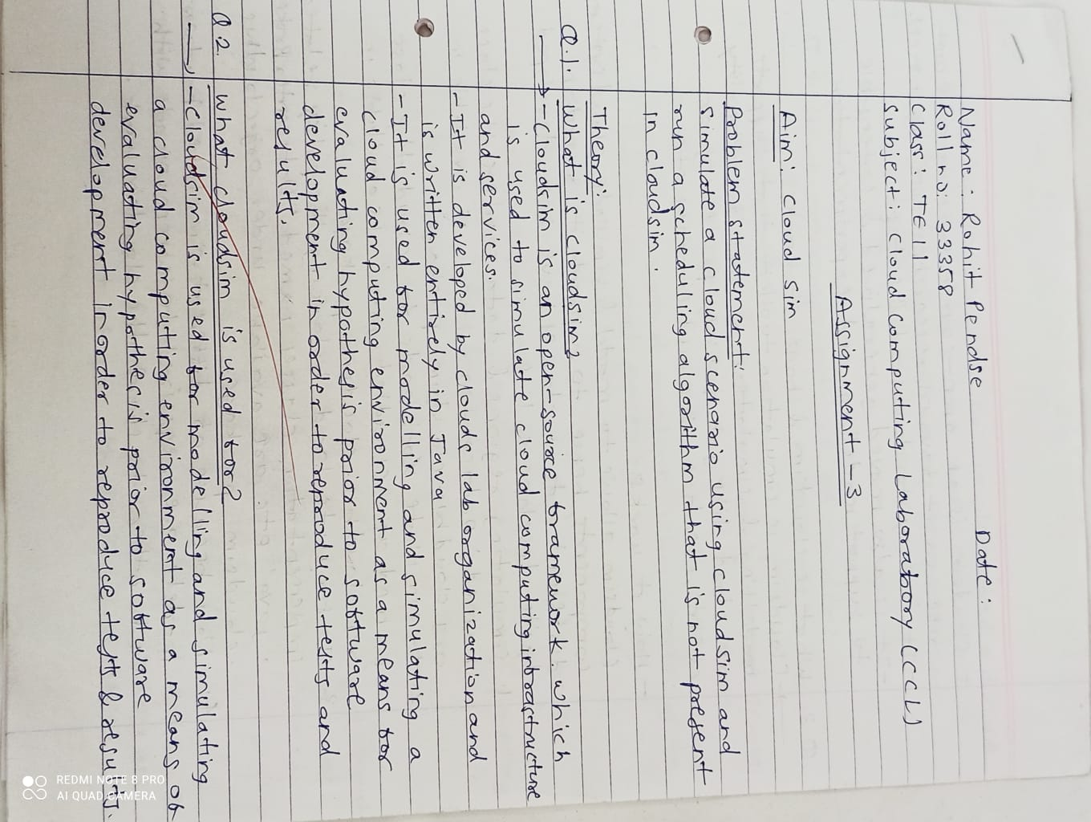

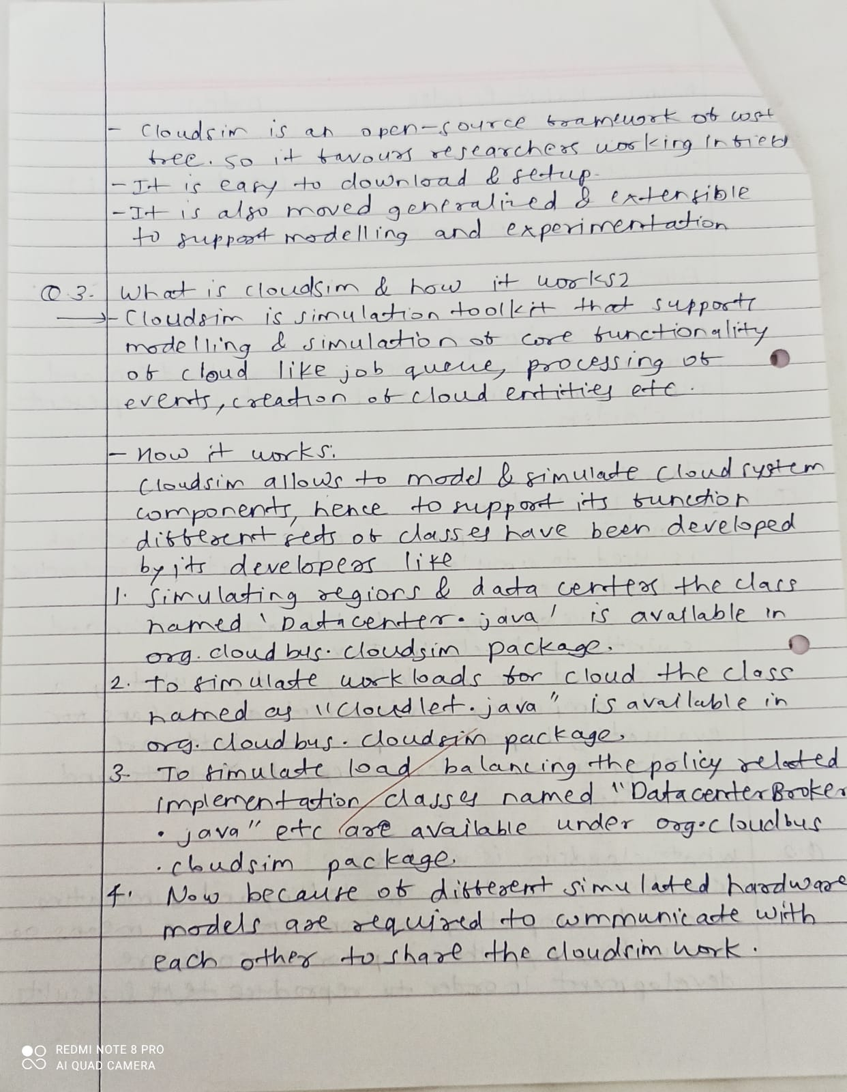

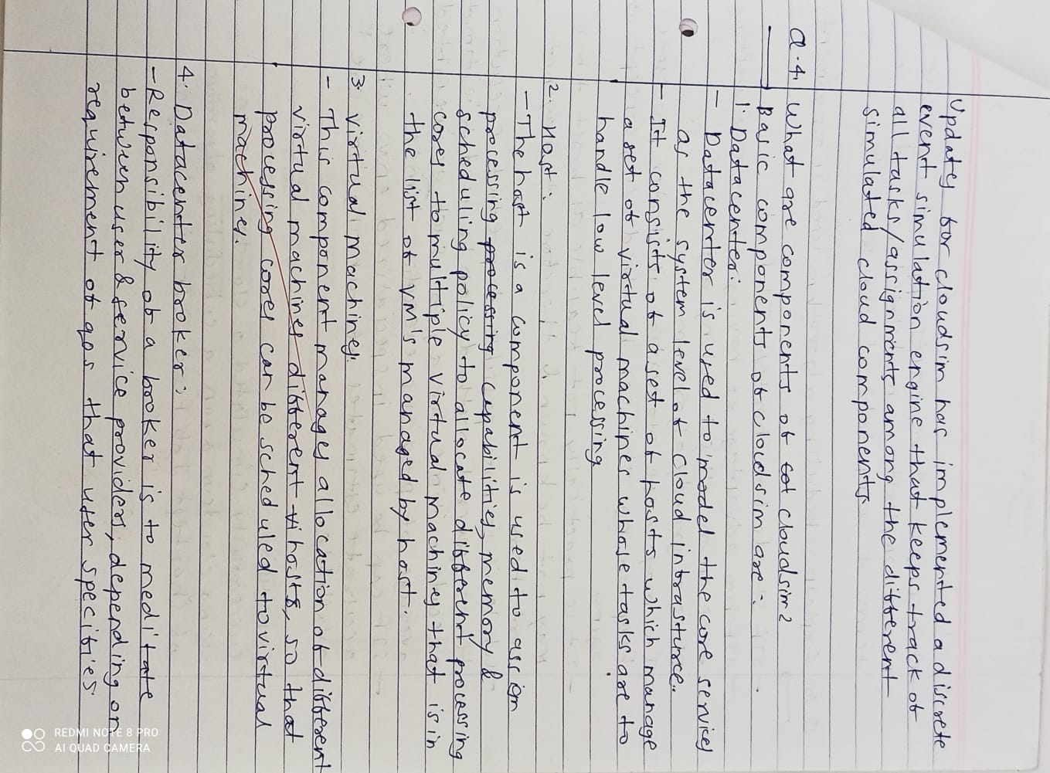

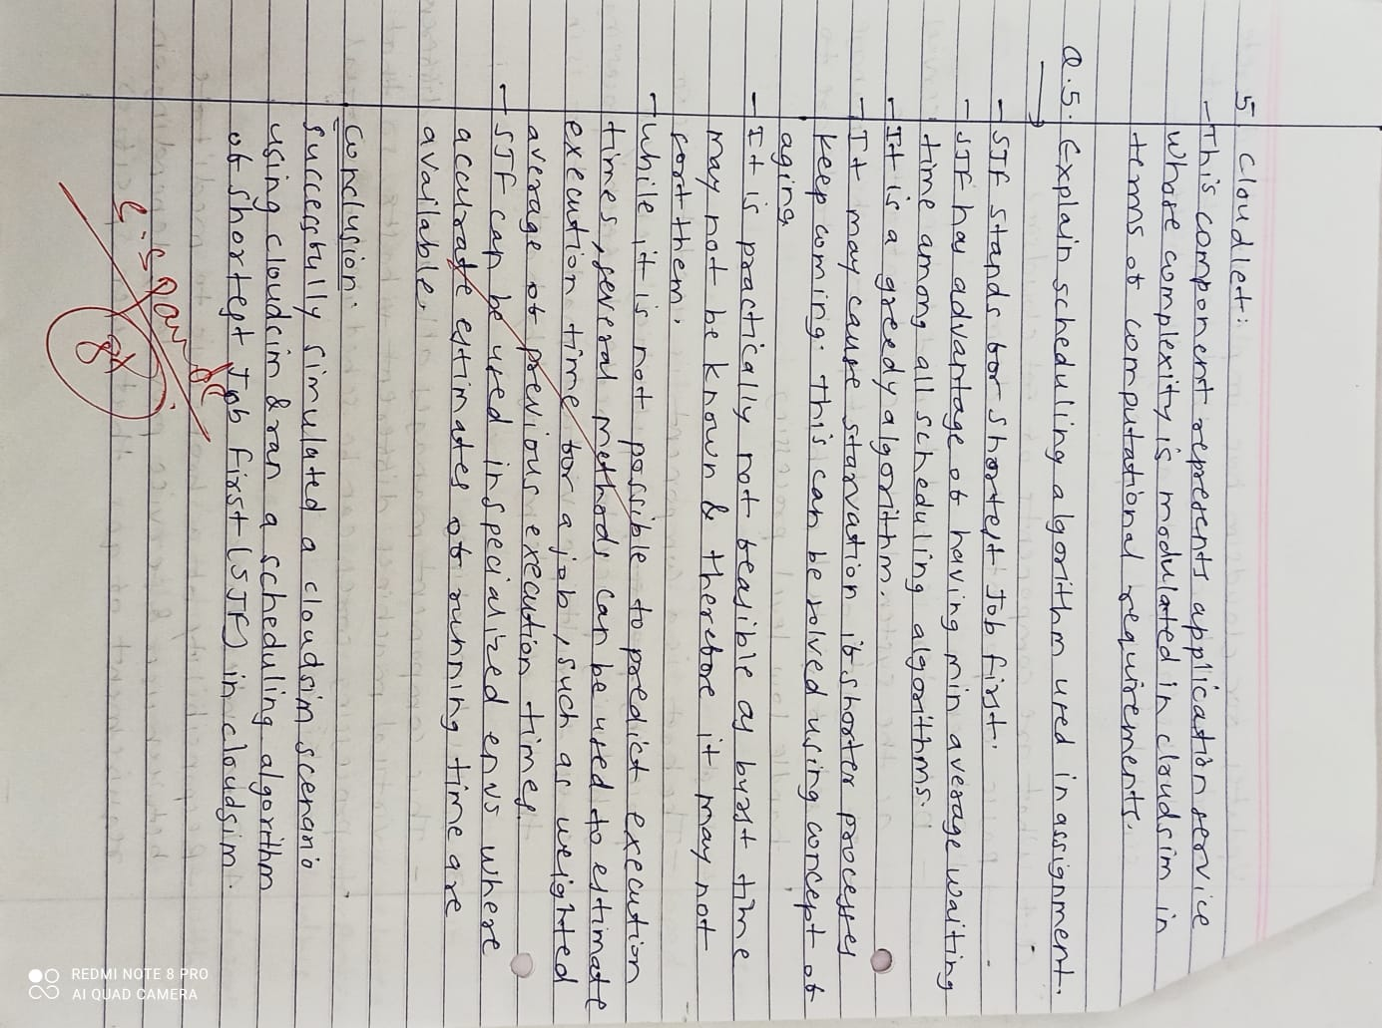

**Code Screenshots:**

1. Constants.java



2. DatacenterCreator.java



3. GenerateMatrices.java



4. SJF_Scheduler.java





5. SJF_DatacenterBroker.java



**Output Screenshots:**





